

TITLE:
The Phenotypic and mechanistic study of salivary exosomal mRNA KPNA2 diagnostic marker in esophageal squamous cell carcinoma

By
Meijuan HAO
Email: hao.mei.juan@163.com
May 2025

PHD
RESEARCH PROPOSAL

In support of PHD application to HKU May 2025 Admissions
Phenotypic and mechanistic study of the KPNA2 gene in esophageal squamous cell carcinoma
I. Introduction about ESCC
1.1 Epidemiology and Clinical Challenges of Esophageal Squamous Cell Carcinoma (ESCC)
Oesophageal cancer, originating from the epithelial cells of the oesophagus, is a major global health burden (Yang et al., 2024). The 2022 Global Cancer Observatory (GLOBOCAN) report states that oesophageal cancer is the 11th most common cancer and the seventh highest cause of cancer mortality globally, with 510,716 new cases and around 445,129 deaths in 2022 (Morgan et al., 2022). Esophageal squamous cell carcinoma (ESCC) is one of the most lethal malignancies worldwide, with a 5-year survival rate of less than 30% (Morgan et al., 2022; Yang et al., 2024). Early diagnosis of ESCC is clinically challenging due to the lack of non-invasive screening and diagnostic methods. Salivary exosomal RNA has been reported to have promising applications in cancer liquid biopsy and in vitro diagnosis (Bray et al., 2024; Li et al., 2023; Lin et al., 2019).
1.2 Overview of KPNA2
KPNA2 has been extensively studied at the protein level, particularly regarding its function in nucleocytoplasmic transport. However, its transcriptomic profile, mutation-related regulation, and functional mechanism in ESCC remain largely unexplored.
Firstly, the KPNA2 mRNA expression levels in human normal tissues and various cancers were identified using data from the Human Protein Atlas database, with data originating from HPA, GTEx, and FANTOM5 projects. The expression levels were further validated using the Oncomine database and the GEPIA online data analysis tool, with data from the TCGA database. KPNA2 mRNA was found to be upregulated in non-small cell lung cancer (NSCLC), gastric cancer, colorectal cancer, breast cancer, hepatocellular carcinoma, and bladder cancer compared to paired normal tissues (Xu & Liu, 2021). Studies have shown that high expression of KPNA2 mRNA is associated with different overall survival and progression-free survival rates (Xu & Liu, 2021).
Secondly, Garritano S discovered that the KPNA2 gene is a new target gene for mutant P53 (Garritano et al., 2013).
Thirdly, KPNA2 (Karyopherin Alpha 2) is a member of the nuclear transport protein family, responsible for mediating the transport of proteins containing nuclear localization signals (NLS), transcription factors, and cell cycle regulatory proteins from the cytoplasm to the nucleus (Y. Chen et al., 2023). Abnormal expression in cancer: Overexpression of the KPNA2 protein is highly expressed in various cancers including esophageal cancer, non-small cell lung cancer and hepatocellular carcinoma. It is significantly associated with tumor staging, metastasis, and reduced patient survival rates (Christiansen & Dyrskjøt, 2013; Han & Wang, 2020).
As a protein with nuclear transport function, the dysregulation of KPNA2 protein may affect the transport of cargo proteins in cancer, thereby promoting carcinogenesis. Many cancer-related proteins have been identified as cargo proteins of KPNA2, including Chk2, BRCA1, NBS1, RAC-1, c-myc, P53, and E2F1, etc (S & X, 2014). The importance of NLS in the translocation of BRCA1 and the direct interaction between KPNA2 and BRCA1 have been confirmed in breast cancer. Among the KPNA2 cargo proteins, E2F1 is particularly noteworthy due to its pivotal role in regulating the cell cycle, proliferation, and differentiation (C. F. Chen et al., 1996). The transcription factor E2F1, which is one of the members of the E2F transcription family encoded by the human E2F1 gene, is a central regulatory factor in cell cycle processes, differentiation, proliferation, and migration (Wang et al., 2012). The 'E2F family' plays an important role in controlling the cell cycle and tumor suppressor gene functions (Wang et al., 2016).
Wang CI and others found that in non-small cell lung cancer, the KPNA2 protein directly interacts with E2F1 and mediates the transport of E2F1 from the cytoplasm to the nucleus, They also confirmed the presence of a Dp1/E2F1 binding site on the KPNA2 promoter (Wang et al., 2012). Van der Watt PJ and others discovered that the Kpna2 promoter contains functional E2F sites, where E2F/Dp1 heterodimers can bind and activate the KPNA2 promoter in cervical cancer cells (van der Watt et al., 2011).
E2F1 is transported by KPNA2, and E2F1 can further enhance the expression of KPNA2, indicating a positive feedback mechanism exists between KPNA2 and E2F1 (Wang et al., 2016). Ma S and others found in ESCC cells that silencing KPNA2 induces G2/M phase cell cycle arrest and can also weaken cell proliferation and survival by reducing the nuclear transport of E2F1 (S & X, 2014). Furthermore, the expression of KPNA2 is regulated by the cell cycle, reaching its highest level during G2/M phase (Christiansen & Dyrskjøt, 2013). Further analysis of the relationship between E2F1 and KPNA2 in ESCC tissues will help deepen the understanding of the carcinogenic mechanism mediated by KPNA2 and propose new strategies for ESCC treatment.
According to the PubMed website (URL: https://pubmed.ncbi.nlm.nih.gov/), a literature search using 'KPNA2 and esophageal squamous cell carcinoma' has been conducted, and currently, two articles have reported on the study of KPNA2 in ESCC.
In 2010, Japanese scholars Makoto Sakai and others conducted immunohistochemical detection of KPNA2 protein expression in 116 ESCC patients undergoing surgical resection and studied the relationship between KPNA2 protein expression and clinical pathological features. The results showed that 60 cases (51.7%) of ESCC patients exhibited positive expression of KPNA2. Positive expression of KPNA2 was significantly associated with poor differentiation (P = 0.015), tumor depth (P = 0.001), lymphatic invasion (P < 0.001), venous invasion (P < 0.001), and tumor stage (P = 0.008). Furthermore, positive expression of KPNA2 was also significantly associated with the Ki-67 labeling index (P = 0.039). Ki-67 is a cell proliferation-related protein closely related to the cell cycle and has been widely used as an indicator reflecting the proliferative capacity of tumor cells in malignant tumor research, with its expression intensity serving as a clinical indicator of tumor prognosis. Univariate analysis showed that ESCC patients with positive KPNA2 expression had a significantly poorer prognosis (P = 0.009). Multivariate analysis results indicated that in this study, only tumor depth and lymph node metastasis, as strong prognostic factors in ESCC, were independently associated with adverse prognosis (Sakai et al., 2010).
In 2014, Chinese scholars Shouzhi Ma and others conducted immunohistochemical analysis on 116 cases of ESCC tissue samples, finding that KPNA2 protein was overexpressed in both ESCC tissues and cell lines. Compared to healthy control groups, the concentration of KPNA2 in the serum of ESCC patients was significantly elevated, with an AUC of 0.804. Additionally, the sensitivity and specificity of the detection were 76.7% and 75.0%, respectively. The study also found that the expression level of KPNA2 increased in various cancers and could function through secretion into the serum. The research utilized small interfering RNA (siRNA) targeting KPNA2 to knock down the levels of KPNA2 in the Kyse510 cell line. The results showed that KPNA2 siRNA suppressed the proliferation and colony formation ability of Kyse510 cells and induced their retention in the G2/M phase (S & X, 2014).
1.3 The Previous Research
During my master's program, I conducted transcriptomic analysis of mRNA from saliva exosomes in ESCC and performed bioinformatics analysis correlating with 24 pairs of tissue samples, identifying candidate genes including KPNA2, followed by clinical validation in a small sample (ESCC=19, HC=21). The results showed that the diagnostic efficacy of saliva exosomal mRNA KPNA2 was 78.9% [95% CI, 63.03%–94.87%], with a sensitivity of 94.74% and specificity of 71.43%, both higher than traditional markers (SCC antigen), preliminarily identifying KPNA2 as a potential diagnostic marker for ESCC. Although the high expression of the KPNA2 gene in saliva exosomes suggests its importance in ESCC, further validation of its expression and function through cell lines and tissue studies is needed to complement the saliva exosome research, to further confirm the consistent overexpression of KPNA2 in ESCC at both transcript and protein levels. The study revealed a significant increase in saliva exosomal mRNA KPNA2 expression in ESCC patients compared to healthy individuals, indicating its potential for non-invasive diagnosis of ESCC.
II. Research Objectives
This study explores the function and mechanism of KPNA2 in ESCC, clarifying the molecular mechanisms of KPNA2 in the occurrence and development of ESCC, and validating its clinical value as a diagnostic marker.
RO1: To confirm the expression level and localization of KPNA2 through cell and tissue detection.
RO2: To clarify the effects of the KPNA2 gene on the proliferation, migration, and cell cycle regulation of ESCC cells through phenotypic validation.
RO3: To explore the interaction between the KPNA2 gene and the E2F1 gene and their regulation of downstream pathways ( G2/M phase regulation).
RO4: To evaluate the sensitivity and specificity of salivary exosome KPNA2 in the early diagnosis of ESCC through clinical translation.

III. Research Questions
RQ1: Does the KPNA2 overexpression correlate with enhanced malignant phenotypes such as proliferation and invasion in ESCC cells?
RQ2: By examining the expression levels and localization of KPNA2 protein, can it be verified that they are consistent with the expression levels of the KPNA2 gene?
RQ3: Is there an increase in exosomal KPNA2 in cell lines?
RQ4: How does KPNA2 promote the progression of ESCC by regulating the cell cycle ( the E2F1 pathway)? What is its molecular mechanism as a salivary exosomal marker?
RQ5: How does KPNA2 drive tumor progression by regulating signaling pathways and exosomal secretion?

IV. Research Methods
5.1 Establishment of Cell Models
Cell Line Selection
ESCC cell lines: KYSE-150, TE-1, EC109, Kyse510, Eca109
Normal control: HET-1A (Normal Esophageal Epithelial Cells)
Cultivation conditions: RPMI-1640 10% FBS, 37℃/5% CO
Summary of the method:
Method | Detection target | Key steps | Expected results
qRT-PCR | mRNA level | Primer Design(KPNA2, GAPDH)，  ΔΔCt method analysis | The expression of KPNA2 mRNA is significantly upregulated in ESCC cells (P value is significant).
Western Blot | protein level | Cell lysis →SDS-PAGE → Transfer → Detection with KPNA2 antibody (1:1000) | KPNA2 protein is highly expressed in ESCC cells.
Immunofluorescence | Subcellular localization | Cell crawling → anti-KPNA2 primary antibody → Alexa Fluor secondary antibody → observed under confocal microscopy | KPNA2 is mainly localized in the cytoplasm/nucleus.
5.1.1 Through Cellular Level Detection, Verify the Expression of the KPNA2 Gene in ESCC Cell Lines.
The primer sequence numbers of F, R, and probe used in the qRT-PCR for GAPDH and KPNA2.
GENE | F | R | Probe
GAPDH |  |  | CTGGCCAAGGTCATCCATGA
KPNA2 | 5’-TTGTGCCCCAACTTGTGAA-3’ | 5’-GCGAGTGCTCCTGCATCAA-3’ | AGGAGCTTCTGAATTGCCAAT
Expected results: The expression of the KPNA2 gene in ESCC cell lines is significantly higher than that in normal cells, consistent with saliva exosome data.

5.1.2 By Examining the Expression Levels and Localization of the KPNA2 Protein, Verify Whether They Are Consistent with the Expression Levels of the KPNA2 Gene
Western Blot (WB)
Objective: to quantitatively detect the expression levels of KPNA2 protein in cells or tissues and verify the translational consistency of transcriptome data.
Steps: sample preparation, extract total protein from cells or tissues, and determine concentration using the BCA method.
Electrophoresis and transfer: Separate proteins using SDS-PAGE and transfer to PVDF membrane.
Antibody incubation: Primary antibody: anti-KPNA2 antibody (e.g., Abcam #ab84440, 1:1000). Secondary antibody: HRP-conjugated secondary antibody (e.g., goat anti-rabbit IgG, 1:5000).
Detection analysis: ECL chemiluminescence detection, quantifying band grayscale values using ImageJ.
Control design: Positive control: cells with known high expression of KPNA2. Negative control: cells with KPNA2 knockdown or normal tissue.
5.1.3 Immunofluorescence (IF), Verifies that KPNA2 is Mainly Located in the Cytoplasm/Nucleus.
Objective: to observe the subcellular localization and dynamic changes of KPNA2 (e.g., nuclear transport function).
Steps: cell fixation and permeabilization: fixed with 4% paraformaldehyde, permeabilized with 0.1% Triton X-100.
Antibody labeling: anti-KPNA2 antibody (green fluorescence) + DAPI (nuclear staining). Confocal microscopy imaging: analyze the overlap of KPNA2 with nuclear labeling (Pearson coefficient).

5.2 Research on the Secretion Mechanism of Exosomes, Connecting Salivary Exosomes with Cell Lines to Explore the Secretion Mechanism of KPNA2
5.2.1 Exosome Isolation and Identification
Collect the supernatant from ESCC cell cultures and isolate exosomes derived from the cell lines.
Isolation methods:
Ultracentrifugation: Centrifuge at 100,000×g for 70 minutes
Kit method: Extraction using Qian Gen (Exo Quick)
Identification markers:
WB validation: positive for CD63 and TSG101; negative for Calnexin (to exclude cell debris)
TEM/NTA: observe vesicle morphology using transmission electron microscopy and analyze particle size (50-150 nm) using nanoparticle tracking analysis.
5.2.2 Detection of mRNA KPNA2 in Exosomes
Validation steps:
RNA extraction: Use TRIzol LS or an exosome RNA extraction kit ( Qiagen exoRNeasy) to avoid genomic DNA contamination. Assess RNA concentration and integrity (RIN > 7).
RT-qPCR: Design KPNA2-specific primers to detect the levels of KPNA2 mRNA in exosomes.
Controls: Positive control, KPNA2 mRNA in total RNA from cells.Negative control: Medium without exosomes or exosomes treated with RNase (degraded free RNA).
A. Establish a correlation of intracellular-exosomal expression
Verify the active secretion mechanism:
If the mRNA level of KPNA2 in the ESCC cell line ( KYSE-150) is significantly higher than in normal cells, and the level of KPNA2 mRNA in the secreted exosomes also increases accordingly, it supports the hypothesis that "cells actively sort KPNA2 to exosomes."
If the intracellular KPNA2 mRNA is high but the content in the exosomes is low, it may suggest the presence of a selective sorting mechanism (RNA-binding protein dependence).
Exclude interference from passive release:
If there is no correlation between the KPNA2 mRNA levels in the cell line and exosomes, it is necessary to consider whether it is due to cell death/lysis release (which needs to be verified through LDH release experiments to assess cell viability).
B. Confirm the validity of the cell model
Standardized experimental system: The cell line is a controllable experimental model, and measuring its mRNA KPNA2 level can clarify its reliability as a source of "highly secreted KPNA2 exosomes."
For example, if KYSE-150 is reported as a KPNA2 high-expression cell line, its baseline expression level must be validated by RT-qPCR to ensure consistency with the literature.
Basis for functional mechanism studies: In subsequent experiments where KPNA2 is knocked down or overexpressed, it is necessary to clarify whether the changes in intracellular and extracellular mRNA levels are associated with exosome secretion capacity ( a decrease or increase in secretion).
C. Support for the interpretation of clinical sample data
Correlation analysis: If KPNA2 mRNA levels are elevated in clinical saliva exosomes, it needs to be confirmed whether they originate from the active secretion of tumor cells (and not normal epithelial or inflammatory cells). By comparing the mRNA KPNA2 levels of ESCC cells with those of normal cells (Het-1A), its tumor specificity can be verified.
Translational medical significance: If the KPNA2 mRNA levels are consistent between the cell line and clinical samples, it can enhance the credibility of "saliva exosome KPNA2 as a biomarker for ESCC."

5.3 Validation with Public Databases
Using RNA-seq data of ESCC from public databases ( TCGA, GEO) to validate the relationship between KPNA2 mRNA expression and prognosis, we previously detected high expression of KPNA2 in tissues, but have not yet performed a prognosis analysis.
5.3.1 Database Selection and Data Extraction
TCGA-ESCA: Screening ESCC Samples (ICD-O-3 code 8070/3)
GEO Dataset: GSE53625 (179 ESCC transcriptome and survival data)
5.3.2 Prognostic Analysis Process
Data Preprocessing: Standardization of KPNA2 expression values (FPKM → log2 transformation)
Optimal cutoff value grouping (determined by the survminer package)
Survival Analysis: Kaplan-Meier curve: Log-rank test comparing OS/PFS between high/low expression groups
Cox Regression: adjusting for age, stage, and lymph node metastasis
Expected Results: High expression of KPNA2 is significantly associated with poor prognosis in ESCC patients (HR>1, P<0.05)

5.4 Research on Cell Phenotype and Function
5.4.1 Gene Manipulation Model
Group | Construction method | Verification indicators
KPNA2 knockdown group | shRNA lentivirus transfection ( shKPNA2-1: 5'-GCAAGATCTTCGAGACCTT-3') → puromycin selection | Knockdown efficiency will be confirmed through WB/qRT-PCR.
KPNA2 overexpression group | KPNA2 cDNA cloned into the pCDH vector → lentiviral packaging → transfection into ESCC cells | WB will be used to verify the expression level.
Reply to the experimental group | Knock down the reexpression of wild-type/mutant KPNA2 in cells. | Specificity of phenotype restoration verification mechanism
5.4.2 Phenotypic Detection
Experiment | Method | Expected results
proliferation capability | CCK-8 (0-72h, OD450 detection), EdU labeling (Click-iT reagent kit), colony formation low-density inoculation (500 cells/well, 7 days crystal violet staining) | The KPNA2 knockdown group will exhibit significantly reduced proliferation, as reflected by lower OD450 values and decreased colony formation
Invasion migration | Transwell (Matrigel coated, 24h), scratch assay (low serum medium, photos taken at 0/12/24h) | The number of invasive cells in the KPNA2 knockdown group will decrease.
Cell cycle | PI staining → flow cytometry (ModFit analysis of G1/S/G2 phase ratios) | Knockdown of KPNA2 will lead to G2/M phase blockage

5.4.3 Functional Validation: Gene Manipulation: shRNA Knockdown of KPNA2, Overexpression of KPNA2, and Rescue Experiments.
Phenotypic Detection: CCK-8, EdU labeling validation, colony formation assays for proliferation experiments; Transwell Matrigel invasion experiments; Transwell and scratch assays for migration validation; Flow cytometry analysis of the cell cycle (G2/M phase arrest).

5.5 Molecular Mechanism Research
5.5.1 E2F1-KPNA2 Regulatory Circuit
Experiment | Technical details | Expected results
RNA Pull-down & Co-IP | Biotin-labeled KPNA2 RNA probe → incubation with E2F1 protein → capture by streptavidin magnetic beads → WB detection of binding | KPNA2 willl directly interact with E2F1
Dual luciferase reporter gene | Construct the KPNA2 promoter fragment (including E2F1 binding site) → co-transfect with E2F1 expression plasmid → detect luciferase activity | Dual-luciferase reporter assays are expected to confirm that E2F1 overexpression enhances KPNA2 promoter activity, supporting a transcriptional feedback regulation mechanism.
ChIP-qPCR | E2F1 antibody immunoprecipitation of chromatin → qPCR detection of KPNA2 promoter region enrichment | E2F1 binding intensity will increase
5.6 Animal Model Validation
5.6.1 Xenograft Tumor Model
A. Establishing a KPNA2 knockdown/overexpression ESCC xenograft model (n=8-10/group).
B. Model type: Xenograft model:
C. Applicable scenario: Verify the effect of KPNA2 on the tumorigenic ability of ESCC cells in vivo.
D. Animal selection: Immunodeficient mice ( BALB/c nude mice or NOD/SCID mice).
E. Experimental cycle and resources
Group | Processing method | Detection indicators/expected results
Control group | KYSE-150 Vector cells (5×10⁵ cells per dose, subcutaneous injection) | Tumor volume, weight, number of metastatic foci
KPNA2 knockdown group | KYSE-150 shKPNA2 cells | Tumor growth inhibition rate
KPNA2 overexpression group | KYSE-150 KPNA2-OE cells | Tumor accelerated growth (increase in size)
Treatment group (optional) | Wild-type cells KPNA2 inhibitor Importazole (10 mg/kg, intraperitoneal injection, 3 times/week) or targeted drugs ( cisplatin) | Synergistic inhibition effect (tumor shrinkage)
5.6.2 Experimental Process
A. Preparation of laboratory animals
Strain and specifications: Order 4-6 week old female BALB/c nude or NOD/SCID mice (Shanghai SLAC Animal Laboratory), ensuring the mice are free from specific pathogens (SPF level).
Adaptive feeding: After arrival, acclimate in an SPF environment for at least 3 days, with free access to water and sterilized feed, and monitor health status.。
B. Cell processing and seeding preparation
KYSE150 cell culture and processing: Group the cells according to the experimental design (e.g., control group, drug treatment group, gene knockout group, etc.).
Digestion and counting: Use pancreatic enzymes to digest logarithmically growing cells, centrifuge after digestion (1000 rpm, 5 min). Resuspend in sterile PBS and count live cells with trypan blue staining (viability must be >90%).。
Cell suspension preparation: Adjust the cell density to 1×10⁷ cells/mL (it is recommended to mix with Matrigel in a 1:1 ratio to improve tumor formation rate).
Cryopreservation: Avoid cell aggregation or death (complete inoculation within 30 minutes).
C. Subcutaneous injection operation
Vaccination site and disinfection: Choose the upper part of the groin in mice (subcutaneous blood vessels are few, reducing the risk of bleeding). Disinfect the skin with 75% alcohol and wait for it to completely evaporate before proceeding.
Injection procedure: Using a 1 mL sterile syringe, inject 0.2 mL of cell suspension subcutaneously at a 30° angle (depth approximately 3-5 mm).
Slowly inject 0.2 mL of cell suspension (containing 2×10⁶ cells) to form a visible papule. Lightly press the injection site to prevent leakage, and use an alcohol swab for disinfection.
D. Tumor growth monitoring
Measurement frequency: twice a week ( Monday and Thursday), measured at fixed time points.
Volume calculation: Measure the tumor's major diameter (L) and minor diameter (W) using a caliper.
Official: V (mm³) = 1/2×L×W²
Data records: Plot the tumor growth curve (horizontal axis: time; vertical axis: volume), labeling the mean ± standard deviation for each group. Any abnormal situations ( ulcers, infections) need to be recorded.
5.6.3 Monitoring Indicators
A. In vivo imaging: IVIS system monitors tumor luminescence intensity (luciferase-labeled cells)
B. Histological analysis: HE staining evaluates necrosis, and Ki-67 staining quantifies the proliferation index.
C. Endpoint treatment: euthanize when the tumor volume reaches 1500 mm³, and take tumor tissue for WB/IHC analysis.
5.6.3 Ethics and Considerations
Ethical Approval: Approval from the Institutional Animal Care and Use Committee (IACUC) is required before the experiment.
Animal Welfare: Tumor volume should be controlled to ≤1500 mm³ to avoid mouse suffering. Operating Standards: Strict aseptic techniques must be followed to prevent infection; anesthesia and euthanasia must comply with AVMA guidelines.
5.6.4 End-of-experiment processing
Endpoint for euthanasia: Week 5 or when tumor volume exceeds 2000 mm³, whichever occurs first
Method for euthanasia after the experiment: euthanized after anesthesia.
Tumor collection and preservation: dissect the subcutaneous tumor, weigh it, and take photos (with a scale reference).
Tissue processing: snap-frozen in liquid nitrogen (-80℃ for molecular experiments). Fixed in 4% paraformaldehyde (for paraffin sections and HE staining).

5.6.4 Experimental Cycle and Resources
Stage | Time | Required resources
Stable cell construction | 4-6 Weeks | Slow virus vector, puromycin, qRT-PCR/Western Blot reagents
Subcutaneous tumor model | 4-6 Weeks | Nude mice, Matrigel, calipers, electronic balance
In situ / transfer model | 8-10 Weeks | In vivo imaging system, surgical instruments
Data Analysis and Organization | 2-3Weeks | GraphPad Prism、ImageJ
5.6.5 Expected Results
KPNA2 low knockdown group: Tumor volume is significantly smaller than the control group (P < 0.01), with reduced metastases.
KPNA2 overexpression group: Tumor growth is accelerated, accompanied by increased nuclear localization of β-catenin and angiogenesis.
Treatment group: KPNA2 inhibitors combined with chemotherapy can synergistically inhibit tumor progression.

5.7 Large-scale Validation of the Diagnostic Efficacy of the Developed Diagnostic Reagent Kit for Salivary Exosomes KPNA2
5.7.1 Exosome Isolation and Quality Control
Clinical samples: Saliva from 200 ESCC patients vs. healthy controls
Isolation method: Differential centrifugation (2000×g→10,000×g→100,000×g)
Quality control standards: TEM confirms morphology, WB detects CD63/TSG101, and NTA analyzes particle size distribution.
Indicator | Method | Goal
Sensitivity/Specificity | ROC curve analysis (comparing SCCA and Cyfra21-1) | AUC > 0.85, sensitivity > 80%
Joint diagnostic efficacy | Logistic regression model (KPNA2 SCCA Cyfra21-1) | Improve the accuracy of early diagnosis (>90%)

VI. Technical Route
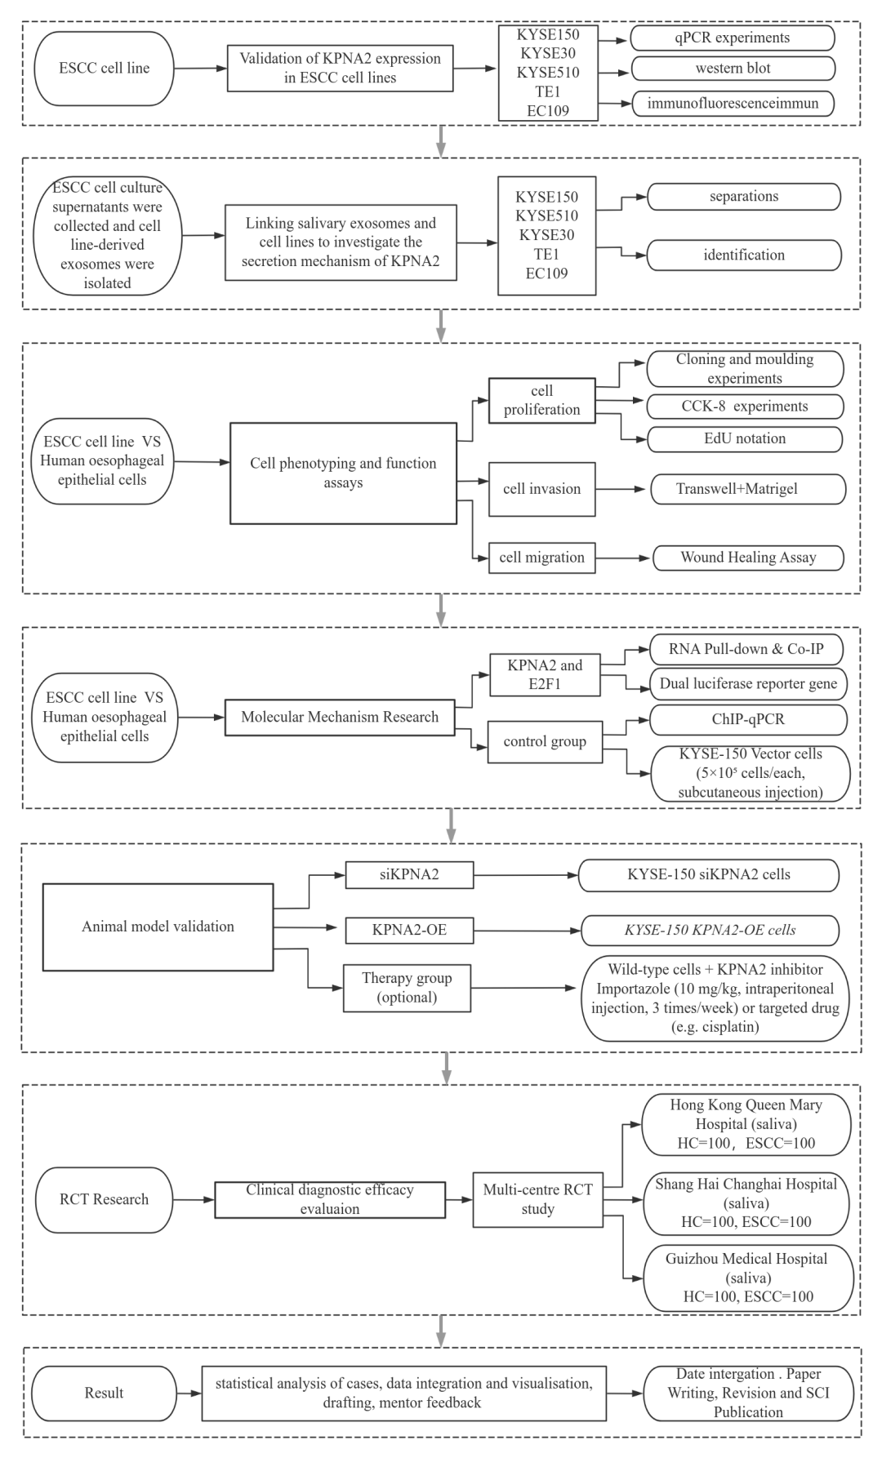

VII. Innovation
7.1 Theoretical innovation: Revealing the E2F1-dependent positive feedback loop as a novel oncogenic mechanism of KPNA2 in ESCC
7.2 Technological innovation: The first use of salivary exosome KPNA2 for early diagnosis of ESCC.
7.3 Translational value: developing a non-invasive diagnostic kit based on KPNA2 to promote applications in precision medicine.

VIII. Significance
8.1 Academic Significance
Publish 1-2 SCI papers in authoritative journals in the fields of oncology or molecular diagnosis, elucidating the molecular mechanism of KPNA2 in esophageal squamous carcinoma and the diagnostic value of exosomes.
Complete the doctoral dissertation "The Mechanism of KPNA2 Regulating the Malignant Progression of Esophageal Squamous Carcinoma and the Application of Exosome Diagnosis," systematically integrating experimental data and clinical translational research.
8.2 Clinical Significance
Invention Patent: Applied for a national invention patent (Title: Non-invasive diagnostic kit and detection method for esophageal squamous cell carcinoma based on salivary exosome KPNA2), covering detection technology, biomarker combinations, and clinical application scenarios.
Technology Transfer: Collaborated with a biopharmaceutical company to promote the CE/CFDA certification of the kit, completing one technology transfer or joint development agreement.
Standardized Process Establishment: Develop the SOP (Standard Operating Procedure) for detecting salivary exosomes KPNA2, and complete validation for sensitivity, specificity, and stability.
Multi-center Validation: Conduct a prospective cohort study with 200 cases in collaboration with three top-tier hospitals, comparing with traditional biomarkers (SCCA, Cyfra21-1), and submit clinical registration application materials.

IX. Timeline
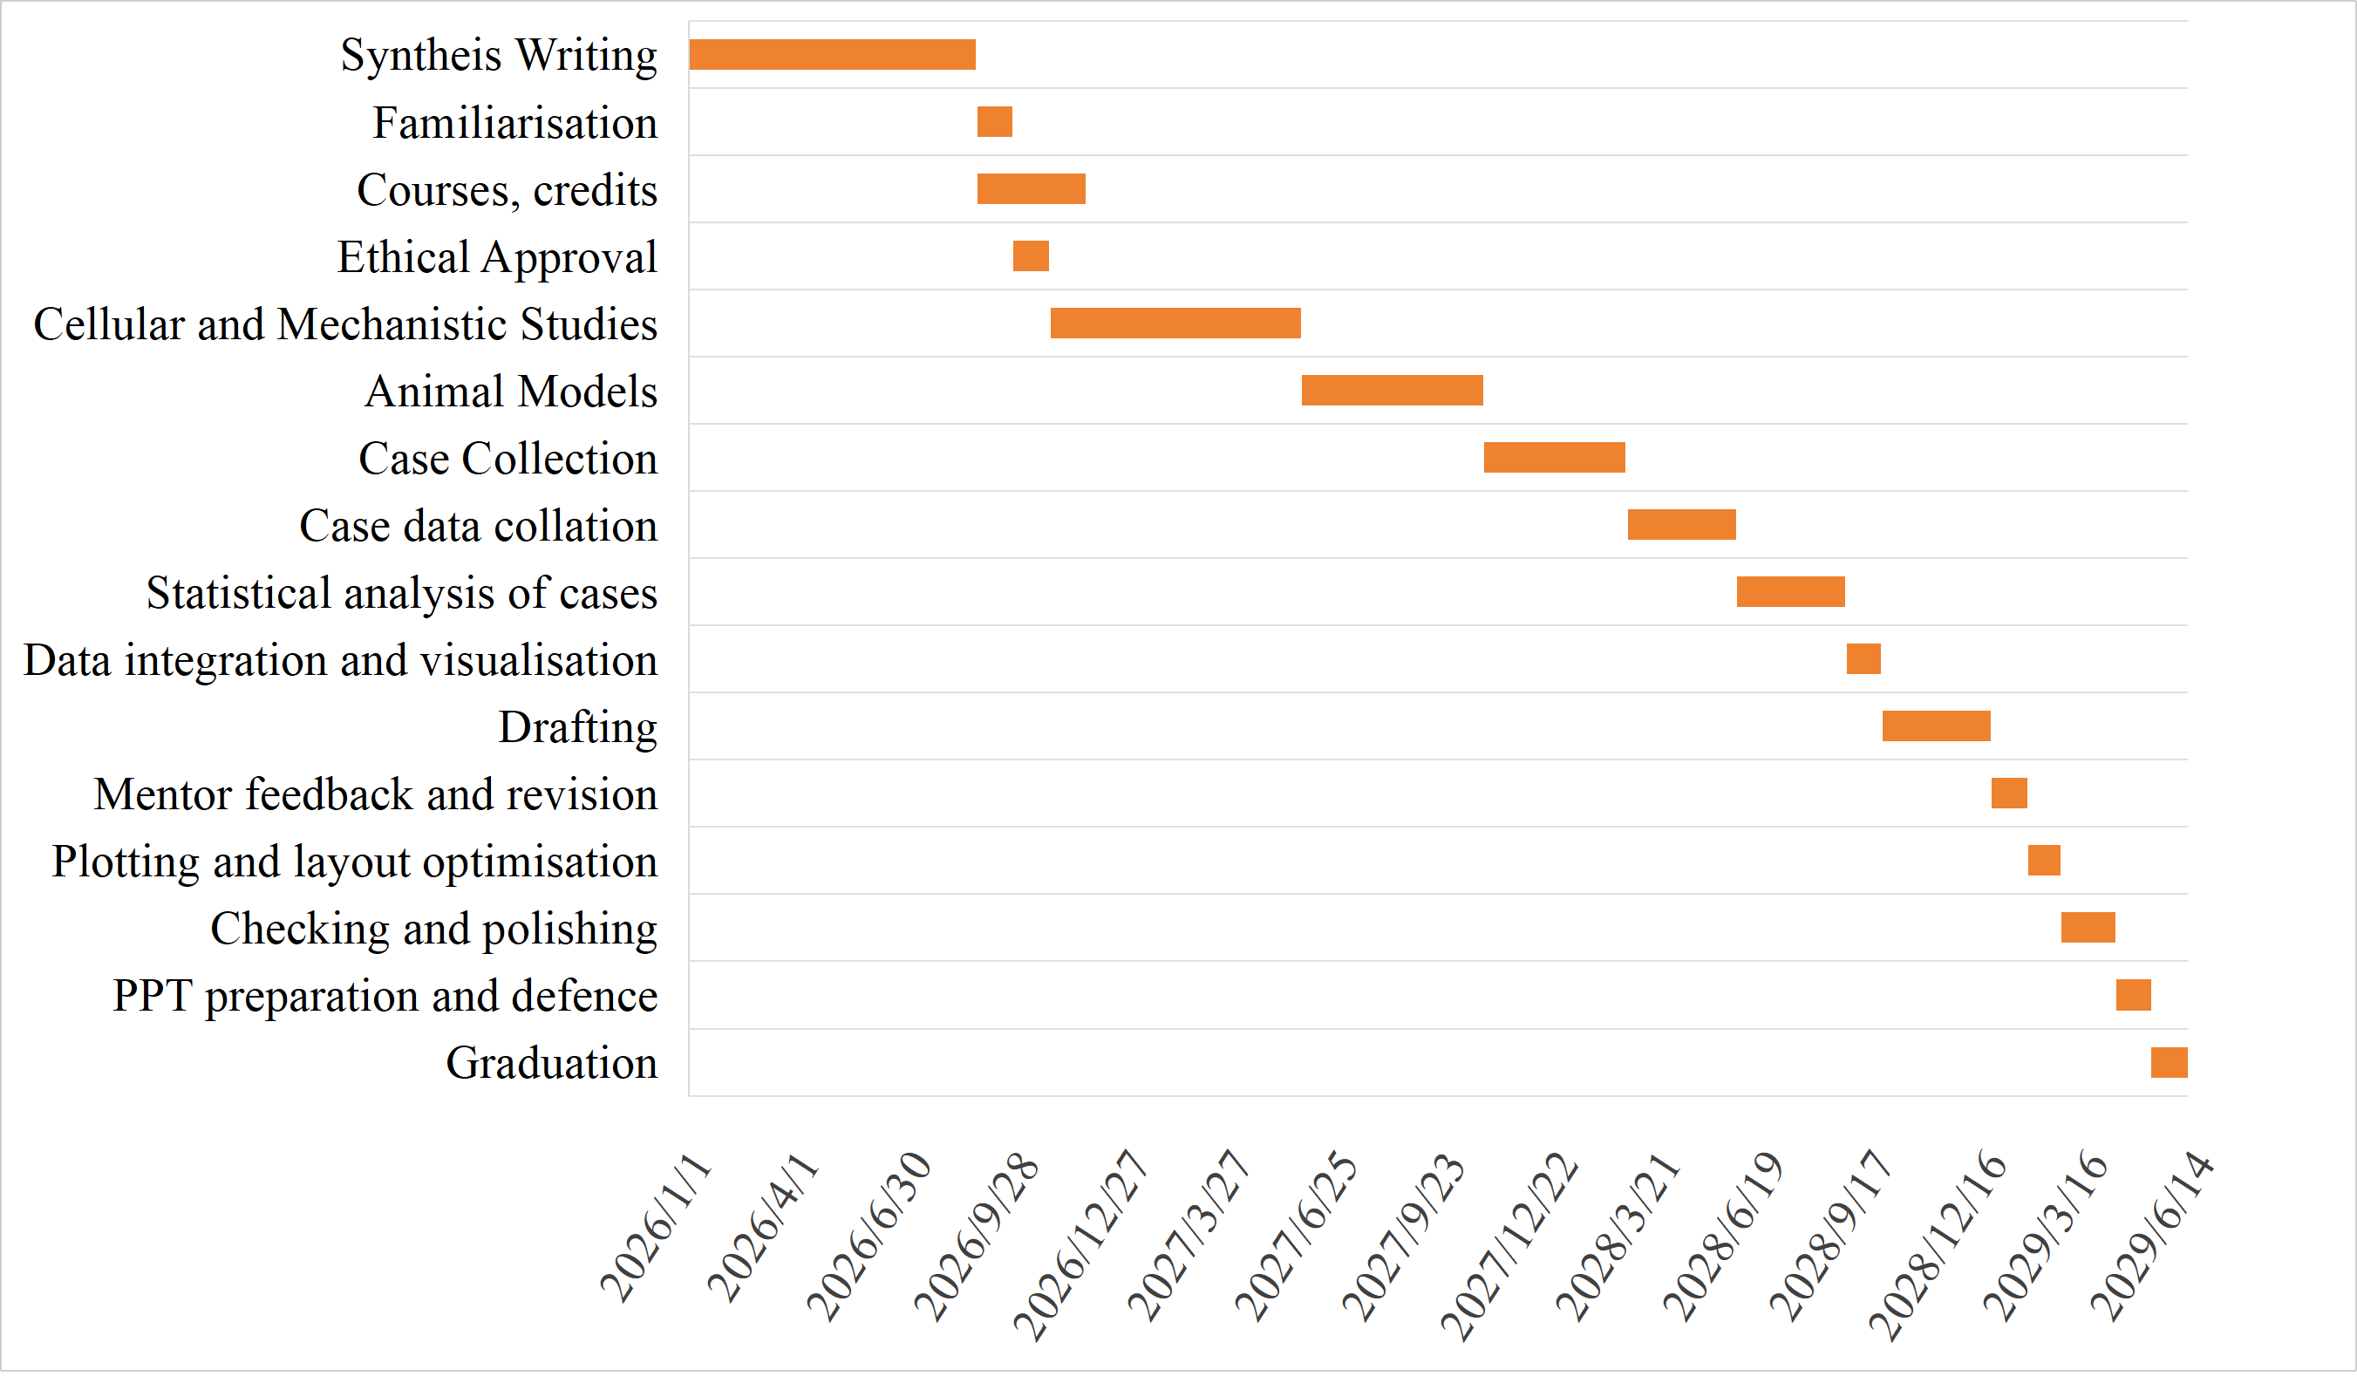

Reference

Bray F, Laversanne M, Sung H, et al. Global cancer statistics 2022: GLOBOCAN estimates of incidence and mortality worldwide for 36 cancers in 185 countries[J]. CA Cancer J Clin 2024; 74: 229–63.
Chen CF, Li S, Chen Y, Chen PL, Sharp ZD, Lee WH. The nuclear localization sequences of the BRCA1 protein interact with the importin-alpha subunit of the nuclear transport signal receptor[J]. The Journal of biological chemistry, 1996, 271(51): 32863- 32868.
Chen Y, Li J, Ma J, et al. ZNF143 facilitates the growth and migration of glioma cells by regulating KPNA2-mediated Hippo signalling[J]. Scientific reports, 2023, 13(1): 11097.
Christiansen A, Dyrskjøt L. The functional role of the novel biomarker karyopherin α 2 (KPNA2) in cancer[J]. Cancer letters, 2013, 331(1): 18-23.
Garritano S, Inga A, Gemignani F, Landi S. More targets, more pathways and more clues for mutant p53[J]. Oncogenesis, 2013, 2(7):e54.
Gu C, Xie L, Li B, et al. Quantification of Tumor Abnormal Proteins in the Diagnosis and Postoperative Prognostic Evaluation of Gastric Cancer[J]. Clinical medicine insights, oncology, 2022, 16: 11795549221104440.
Han Y, Wang X. The emerging roles of KPNA2 in cancer[J]. Life sciences, 2020, 241: 117140.
Li L, Jiang D, Zhang Q, et al.. Integrative proteogenomic characterization of early esophageal cancer Nature communication. 2023 Mar 25;14(1):1666.
Lin Y, Dong H, Deng W, et al. Evaluation of Salivary Exosomal Chimeric GOLM1-NAA35 RNA as a Potential Biomarker in Esophageal Carcinoma[J]. Clinical cancer research : an official journal of the American Association for cancer research, 2019, 25(10): 3035-3045.
Ma S, Zhao X. KPNA2 is a promising biomarker candidate for esophageal squamous cell carcinoma and correlates with cell proliferation[J]. Oncology reports, 2014, 32(4): 1631-1637.
Morgan E, Soerjomataram I, Rumgay H , et al. The Global Landscape of Esophageal Squamous Cell Carcinoma and Esophageal Adenocarcinoma Incidence and Mortality in 2020 and Projections to 2040: New Estimates From GLOBOCAN 2020. Gastroenterology. 2022 Sep;163(3):649-658.e2.
Sakai M, Sohda M, Miyazaki T, et al. Significance of karyopherin-{alpha} 2 (KPNA2) expression in esophageal squamous cell carcinoma[J]. Anticancer research, 2010, 30(3): 851-856.
van der Watt PJ, Ngarande E, Leaner VD. Overexpression of Kpnβ1 and Kpnα2 importin proteins in cancer derives from deregulated E2F activity[J]. PLoS one, 2011, 6(11): e27723.
Wang CI, Chen YY, Wang CL, et al. mTOR regulates proteasomal degradation and Dp1/E2F1- mediated transcription of KPNA2 in lung cancer cells[J]. Oncotarget, 2016, 7(18): 25432-25442.
Wang CI, Chien KY, Wang CL, et al. Quantitative proteomics reveals regulation of karyopherin subunit alpha-2 (KPNA2) and its potential novel cargo proteins in nonsmall cell lung cancer[J]. Molecular & cellular proteomics: MCP, 2012, 11(11): 1105- 1122.
Xu C, Liu M. Integrative bioinformatics analysis of KPNA2 in six major human cancers. Open Med (Wars). 2021 Mar 30;16(1):498-511. doi: 10.1515/med-2021-0257.
Yang H, Wang F, Hallemeier CL , et al. Oesophageal cancer. Lancet. 2024 Nov16;404(10466):1991-2005.

