Awakening the Forgotten: A Documentary Animation of Local Myths in Chongqing Mountain Communities as Participatory Archaeology

1. Statement of Purpose (20%)
1.1 Chongqing is called the "Mountain city". Chongqing has a mountainous area of 62,000 square kilometres, accounting for about 75 per cent of the city's total area, more than 30 percentage points higher than the national average. In districts and counties such as Pengshui, the mountainous area accounts for more than 99%. The "mountainous area" is thus defined as the rudimentary urban condition of Chongqing (Zhou, S.S. 2025). Consequently, diverse mythological systems rooted in topographical features have emerged, reflecting the deep interconnection between landscape and indigenous belief structures (Chongqing Academy of Social Sciences. 2023, Li, X. 2025, Xiong, D. & Cheng, S. 2004). Due to the flow of population to cities and the decline of villages, in some areas, people aged 60 and above account for 61.3% or more of the permanent resident population (Tian, F.L. 2025) These intangible cultural assets, preserved primarily through oral narratives of the elderly and absent from formal archaeological documentation, face imminent extinction within the next decade. Existing research on Chongqing’s traditional villages tends to concentrate on isolated case studies and spatial typologies, overlooking dynamic relationships across spatial and temporal scales—from local to regional, material to symbolic (Song, Z.J. 2022). There is a focus on centralised narrative and a lack of participatory animation as rituals/records; In its mainstream heritage practice, it focuses on material preservation and textual documentation, excluding visual narrative.

1.2 This study responds to the marginalisation and erosion of terrain-specific Indigenous mythologies in Chongqing’s mountainous regions by proposing participatory documentary animation as a culturally embedded method for visual archiving and revitalisation. This participatory documentary animation model is divided into three dimensions: First, I will use animation to organise oral history and myths of specific landscapes and invite Indigenous communities to participate together to form a visual archive of the mythological system. The second dimension of the study probes documentary animation as “post-animation,” employing a cross-media methodology that prioritises the embodiment of knowledge, emotional resonance with Indigenous epistemologies, and the preservation of cultural continuity. Finally, it will explore how this methodological model can be applied to other marginalised communities globally facing similar cultural extinction, such as the North region in the UK and the Kankincho area in Yamagata Prefecture, Japan.

2. Research questions (5%)
• How can participatory animation reconstruct and archive terrain-based Indigenous myths that lack visual or textual representation?
• What are the ethical, epistemological, and aesthetic implications of involving Indigenous communities in the animated retelling of myth?
• How can this model serve as an alternative archival practice within visual anthropology and heritage science?
• How to design the variables of this model to adapt to other Indigenous cultural scenarios in the world?

- Literature Review (35%)
  - Animated documentaries as site-specific revival rituals are rarely targeted for research due to the lack of practical cases. In contrast, scholars are more inclined to discuss the possibility of animation as A documentary (Honess Roe, A. 2013), or media archaeology of particular cultures (Nagtegaal, J. 2023), Analyse the ontological framework (Murray et al. 2021) and developments in the new media reality (Ehrlich, N. 2021).

  - Traditional research approaches have contributed to the tendency of animated documentaries in East Asia, Europe, and the United States to adhere to linear narrative structures and cautious, conventional styles, often resulting in mere reiterations of the facts rather than fostering innovative or critical visual inquiry. Regarding animation's representation of Indigenous cultures, there are only some ethnographic style imitations and "image animation" as an aesthetic tool. For instance, it has documented, simulated, and abstracted images of shamanic rituals in Kerala, India, Aboriginal Australia, and the Amazonian tribes (Morphy et al. 2006, Pink et al. 2022, Ruby, J. 2000). Indigenous engagement in earlier animated ethnographies was minimal—limited primarily to voice recordings and character renderings—lacking substantive, site-specific interaction or co-creative authorship (Bishop, C. 2012; Kester, G.H. 2004), it is general and lacks specific encounters with the location. Previous scholarship has largely instrumentalised animation as an aesthetic tool, failing to fully explore its participatory and locational potential as a medium for cultural revitalisation.

This cautious and unconfident phenomenon of documentary imitation (particularly interview recording animation) creates a core contradiction in animated documentaries. On the one hand, the documentary nature of animation is still excluded from mainstream archival science (Edward et al. 2021; Francis et al. 2011), on the other hand, the significant devolution of the “hauntological temporality” of animation under the "realist" principle (Cholodenko, A. 2018). however,the dynamic reconstruction function of the image and the image translation function of memory of this discourse are precisely the methods that can fold time and revive landscape culture (Wall, G. 2022).

3.4 This approach can be developed in the form of "hauntological ethnography" (Barad, K. 2017), using dynamic, virtual, and mixed multi-image forms to express multiple temporal layers of the location, which in itself is the overall participation of the location elements. Including Indigenous participants transforms the project into a ceremonial act of cultural revival, reinforcing the continuity of local traditions through collaborative engagement.

These three dimensions—methodological development, archival formalisation, and participatory expansion—are essential for advancing animated documentaries as a tool capable of engaging with the temporal and spiritual complexity of place-based cultural memory. In short, what is lacking in the current research is: Practical research on participatory animated documentaries lacks Indigenous communities and mythological fields in the mountainous terrain of East Asia;Archival expression of the multi-temporality of locations lacks the intervention of an effective multi-temporal virtual image method that can both dynamically reconstruct images and translate memory images; Currently, there is a critical absence of a structured participatory animated documentary framework that encompasses the full trajectory of cultural revival—from site-based investigation to ritual enactment.

4. Research Methodology (35%)
4.1 In participatory animation, the research methodology unfolds from four sequential dimensions. Phase One: Oral History Collection. This phase involves ethnographic fieldwork in sparsely populated mountain villages with distinctive topographies, where local elders narrate terrain-related myths. Data is gathered through family storytelling sessions, village discussions, and archival reviews. Rooted in anthropological methodology, this stage emphasises the cross-verification of multiple oral accounts to reconstruct narrative models that approximate premodern mythological structures as accurately as possible. Phase Two: On-site Archaeology of the Location. Go to specific sites associated with these oral histories, sample site materials, and analyse why the sites are strongly associated with these oral texts. The method is an on-site visit, and image collection location. Phase Three entails a Participatory Animation Workshop informed by Honess Roe’s framework for documentary animation and Birgitta Hosea’s concepts of extended and post-animation, producing cross-media visualisations rooted in collaboratively sourced oral histories. The approach is participation in animation、physical participation in animation、thinking participation in animation art. Phase Four: Site Revival Ceremony. Based on these cross-media animated documentary productions, animated festivals are held at the locations discussed in the animation. This dimension, from the perspectives of anthropology, archaeology, and visual culture, explores how specific nature has influenced the spirit and behaviour of human groups in the early and contemporary development of humanity, seeks a documentary expression in fictional dynamic images, and adds the human spirit to nature to restore the original civilization. The approach involves Art festivals, animation ceremonies, and Seminar activities.

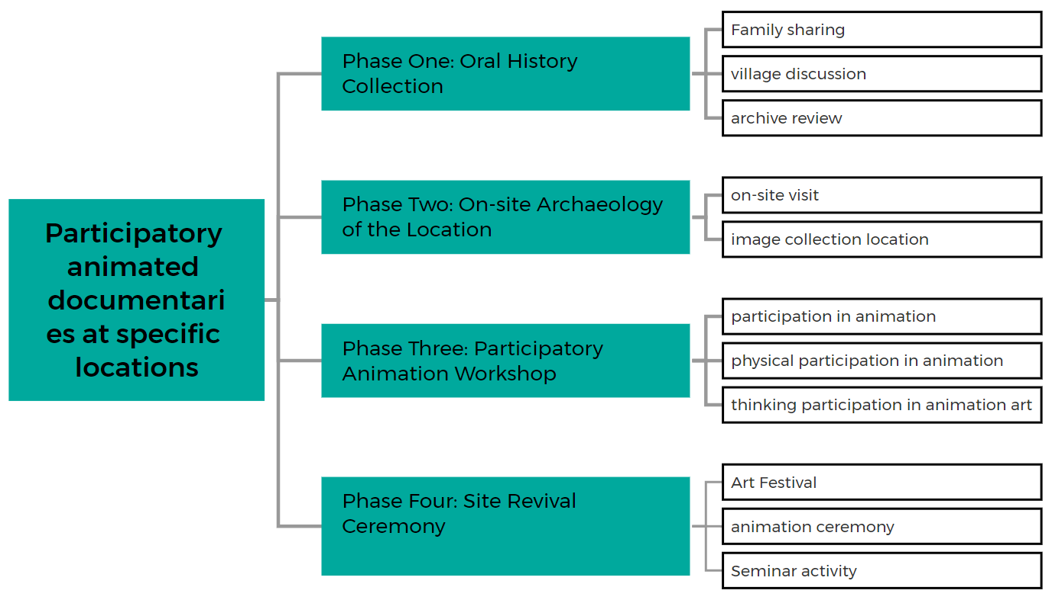

This framework has been applied in three separate case studies, each aligned with one of the model’s three methodological dimensions. Each set was developed in the mountainous area of Chongqing. There are so many dialects in the mountainous area of Chongqing that it is difficult to conduct research. I , as an Indigenous, can communicate without barriers; All cases were conducted in Chongqing’s mountainous regions, where high dialectal diversity presents significant linguistic challenges to conventional research methodologies.

The first group was in the mountainous area of Youyang, Chongqing. Through the oral reconstruction of myths such as “Niawa Cave,” “Shen Cave,” and “The Ox That Wouldn’t Turn around for Three Days,” a community art festival was organised, which revitalised intergenerational transmission of folklore and reshaped contemporary narratives and communal practices. The second time was at Degan Primary School in Jiangjin District, Chongqing. Through the oral history of the elders, it was discovered that the school was once a well-known local family temple in the last century. We invited the children of the school to participate in this animation, which led the school to start protecting the temple site and interrogate the location in the curriculum. These two projects respectively reflect the role of participatory animated documentaries in two different groups of test models, mountainous and rural, natural and human, and show the vast academic space and social significance behind them. The third project undertakes fieldwork at six source points of the two principal rivers in Chongqing’s Banan District, inviting six proximate villagers to collaboratively produce animations using right those river sources’ river mud and water, which are then presented in a downstream community art festival as a form of environmental storytelling.

Ethical considerations: Ethically, this project ensures co-authorship with Indigenous participants, granting them full rights to exhibit and distribute the works; dialectal recordings and related materials will be archived locally, with all Indigenous contributors formally identified and acknowledged.
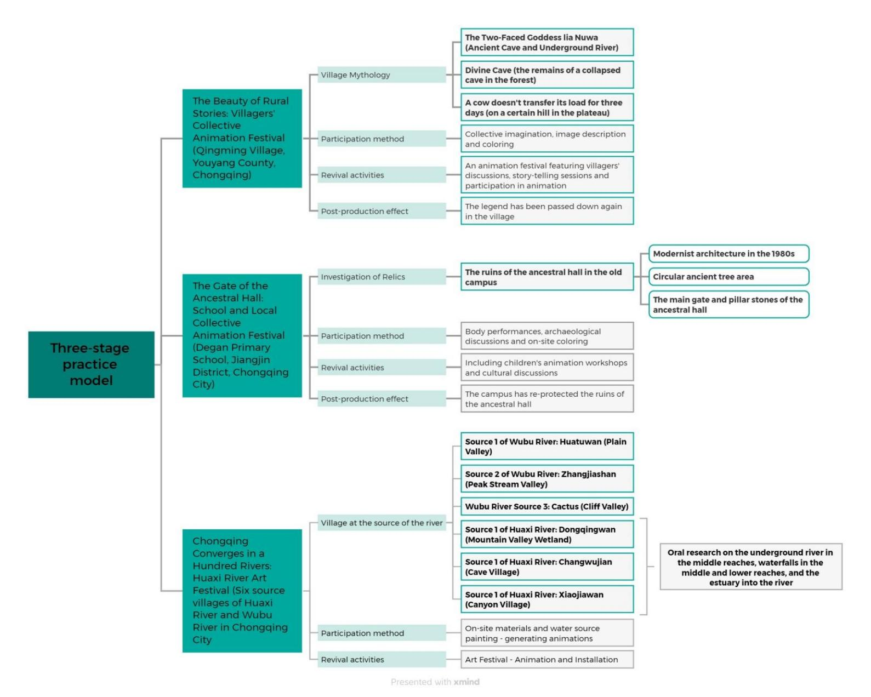

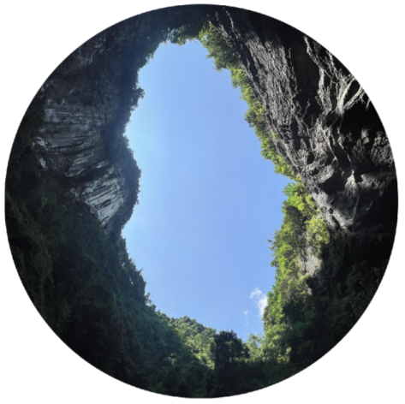
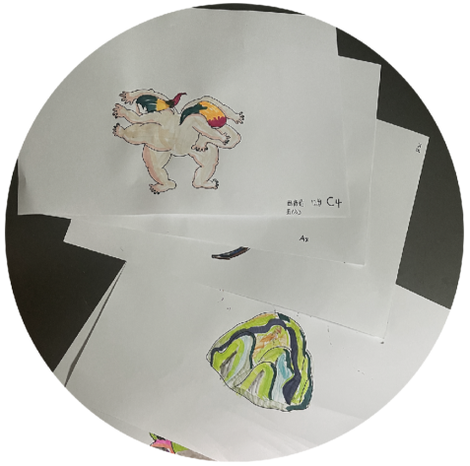

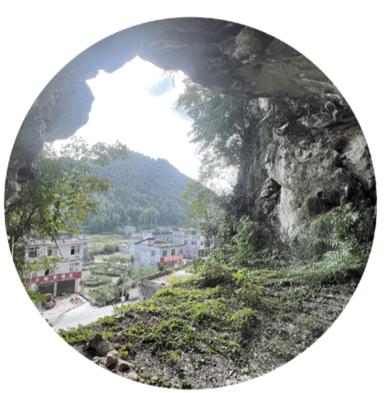
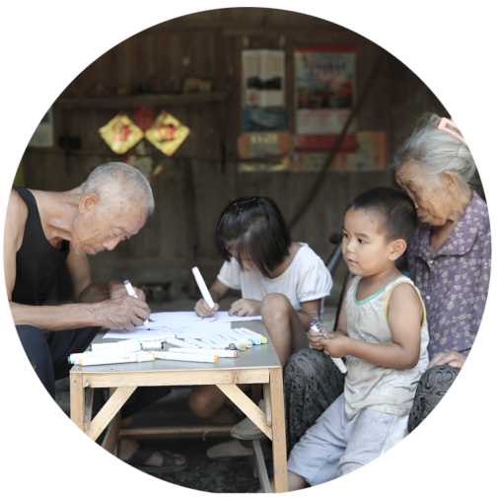


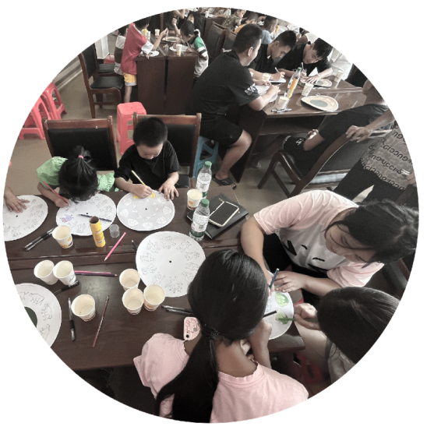

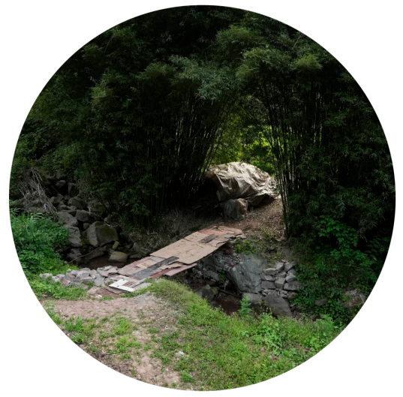
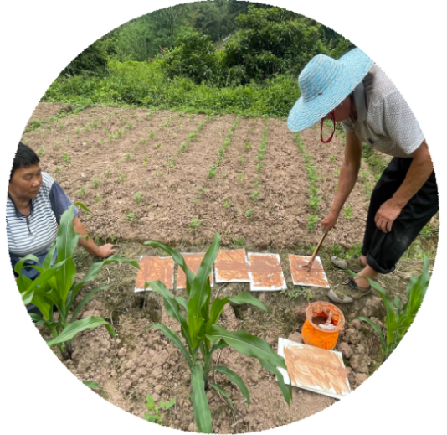

4.2 This study is underpinned by three interrelated theoretical frameworks that collectively inform its methodology and critical analysis. The first is Visual Anthropology (MacDougall, D. 2019, Pink, S. 2015), which integrates visual media into animated ethnographic documentation. Next is Participatory Art and Community Empowerment (Bishop, C. 2012, Kester, G.H. 2004) to examine the ethical and power dynamics in cooperative cultural production. Finally, there is Location and Animation Archaeology (Barad, K.2017, Hosea, B. 2019, Lu, T.T. 2024), which goes beyond traditional cinematic media forms and views animation as a tool of cultural memory, that is text and visual analysis, participation in observation and interviews, and Archival practice of cross-media animation. Textual and visual analysis focuses on decoding the narrative structure, stylistic choices, and symbolic motifs within the animations, particularly as they relate to Indigenous mythologies. Participation in observation and interviews mainly documents the villagers' imagination of myths, their experiences of participating in workshops, and the impact of the animation festival on Indigenous culture. The archival practice of cross-media animation involves the non-linear reproduction and revival of location archives through animated documentaries that integrate thicky time.

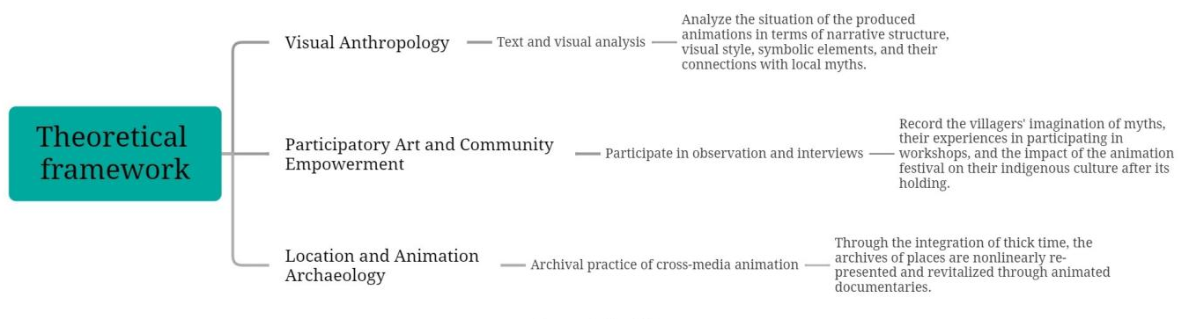

- Statement of Significance (5%)
· Developed a new approach to using animation in oral history documents;
· Expanded the approach of participatory media as an archive of heritage;
· Advanced visual anthropology through the storytelling of topographic myths;
· Increase local cultural institutions → Provide a model for low-literacy, image-rich community storytelling to build a platform for cultural return and recognition (festivals)
· Consider moderate scaling: Pilot the festival in 2-3 villages and document the community's response.

6. Provisional Timetable
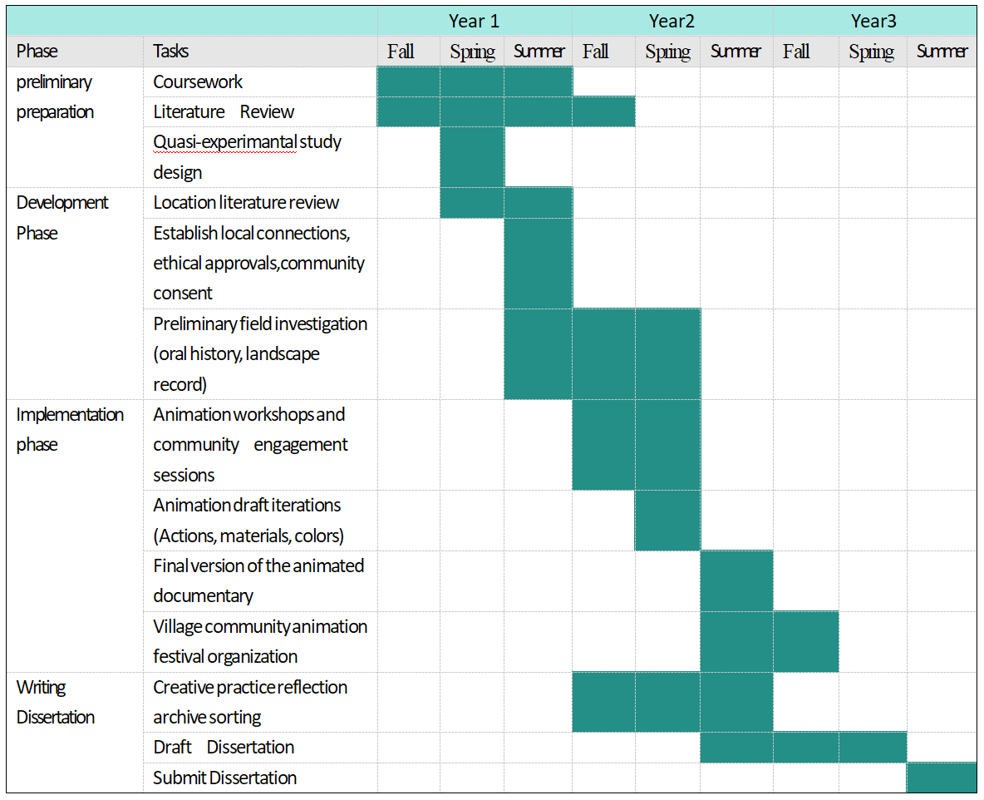

- Bibliography
·Barad, K.​2017. “Troubling Time/s and Ecologies of Nothingness: Re-turning, Re-membering, and Facing the Incalculable”. New Formations, 92(1), 56-86.
·Wall, G. 2022. Trans-corporeal photographies: landscapes of a more than human world. In Relate North #9 (pp. 62-81). Viseu, Portugal: InSEA Publications.
·Cholodenko, A. 2018. “Tears in Rain”: Hyper-Memory, Hyper-Basements, Hyper-Haunted Houses [Conference presentation]. 3rd Annual Conference of Chinese Animation Studies, Chengdu University, Chengdu, China.
·Zhou, S.S. 2025. Listening to Yuzhou Lecture to Interpret the geographical and cultural Beauty of the City of Mountains and Waters [Listening to Yuzhou Lecture: Interpreting the Geographical and Cultural Beauty of the Mountainous City]. Chongqing Daily – New Chongqing [online]. Available from: https://cqrb.cn/wenlv/shangyou/2025-04-24/2252518_pc.html [Accessed 3 May 2025].

·Song, A Cultural District Perspective on Traditional Villages in Chongqing and Their Conservation Development. Master Electronic Journal Four (4). [Online]. Available at: https://doi.org/10.27670/d.cnki.gcqdu.2020.002504 (Accessed 3 May 2025). Funded by Chongqing sub-project of the National Natural Science Foundation of China: Research on the Rural Landscape, Heritage Value and Protection of Traditional Villages in Southwest Ethnic Areas based on Cultural Ecology.
·Tian, F.L.2025. Current Situation and Countermeasures of Rural Left-behind Elderly in Chongqing. Chongqing Aging Office.
·Li, X. (2025). Chongqing New Mountain Ghost: The New Mountain Ghost of Chongqing: Unveiling the Modern Charm Behind Ancient Legends Unveiling the Modern Charm of an Ancient Legend]. Journal of Chinese Folklore, 45(3), 78-94.
Xiong, D. & Cheng, S. (2004). Myths and Legends of Bayu Culture. Chongqing: Chongqing Publishing House. ISBN: 753666499.
·Chongqing Academy of Social Sciences. (2023). Historical Geography Analysis of Mountain Myths in Chongqing. Chongqing: Chongqing Publishing House.

·Honess Roe, A. 2013. Animated Documentary . New York : Palgrave Macmillan.
·Pilling,J. (Ed.). 2012. Animating the Unconscious: Desire, Sexuality and Animation. New York: Columbia University Press.
·Formenti, C. 2022. The Classical Animated Documentary and Its Contemporary Evolution . London: Bloomsbury Academic.
·Murray, J.&Ehrlich,N. (Eds.).2021. Drawn from Life: Issues and Themes in Animated Documentary Cinema .Edinburgh: Edinburgh University Press.
·Nagtegaal, J. 2023. Politically Animated: Non-fiction Animation from the Hispanic World. Canada: University of Toronto Press.
·Nash, K.& Hight, C. (Eds.). 2014. New Documentary Ecologies: Emerging Platforms, Practices and Discourses . London: Palgrave Macmillan.
·Kriger, J. 2011. Animated Realism: A Behind The Scenes Look at the Animated Documentary Genre, london: Routledge
Lu, T.T. 2024, Post - animation. Chongqing: Chongqing Publishing House.
·Ehrlich,N.2021, Animating Truth: Documentary and Visual Culture in the 21st Century.Edinburgh: Edinburgh University Press.
·Buchan,S.2013,Pervasive Animation, london: Routledge
·Haavisto, E. and Wall, G. 2024. Shielin-bough: Building collaboration across the North.[Online].
[Accessed 12 March 2025].Available from: https://radar.gsa.ac.uk/9917/
·Corrado, E.M.&Moulaison,H.L.(Eds.).2021,2nd D. Maryland: Rowman & Littlefield
·Blouin, F.X., Jr. and Rosenberg, W.G. 2011. Processing the Past: Contesting Authority in History and the Archives. New York: Oxford University Press.
·Yang, C.F. 2021. Changbai shan chongbai yu Changbai shan shenhua yanjiu [The worship of Changbai Mountain and the study of Changbai Mountain mythology]. Manzu Yanjiu [Manchu Studies]. [Online]. 2021(4), Pp. 94-102. [Accessed 20 June 2024]. Available from: https://doi.org/10.3969/j.issn.1006-365X.2021.04.012
·Liu, J.X. 2020. The modern evolution of Hongshan folk legends. Communication Power Research. [Online]. 9, Pp. 40 and 41. [Accessed 18 April 2025]. Available from: https://doi.org/10.20112/j.cnki.issn1007-5828.2020.09.026
·Collier, J. and Collier, M. 1986. Visual Anthropology: Photography as a Research Method. Albuquerque: University of New Mexico Press.
·Morphy, H. and Perkins, M. (Eds.) 2006. The Anthropology of Art: A Reader. Malden: Blackwell Publishing.
·Pink, S., Hahn, O. and Dietze, R. (Eds.) 2022. Digital Materialities in Anthropology: Beyond the Digital Divide. London: Routledge.
·Ruby, J. 2000. Picturing Culture: Essays on Film and Anthropology. Chicago: University of Chicago Press.
·Bishop, C. 2012. Artificial Hells: Participatory Art and the Politics of Spectatorship. London: Verso.
·Kester, G.H. 2004. Conversation Pieces: Community and Communication in Modern Art. Berkeley: University of California Press.
·Barker, J. 2017. The Tactile Eye: Touch and the Cinematic Experience. Berkeley: University of California Press.
·Hosea, B. 2019. Experimental animation: From analogue to digital. Loudon: Routledge.
·Doty, W. G. 2017. Ecocriticism and Myth: Nature, Culture, and Narrative. London: Routledge.
·Blank, T. J. (Ed.). 2013. Oral Tradition in the Digital Age. Logan: Utah State University Press.
·Bauman, R. 1986. Storytelling as Performance: The Ethnography of Oral Narrative. Bloomington: Indiana University Press.
·Lindow, J. 2001. Norse Mythology: A Guide to Gods, Heroes, Rituals, and Beliefs. Oxford: Oxford University Press.
·MacDougall, D. 2019. The Looking Machine: Essays on Cinema, Anthropology, and Documentary Filmmaking. Manchester: Manchester University Press.
·Pink, S. 2015. Digital Ethnography: Principles and Practice. London: Sage.
·Stewart, P. J., & Strathern, A. (Eds.). (2003). Landscape, memory and history: Anthropological perspectives. London: Pluto Press.
·Coomans, T., Cattoor, B., & De Jonge, K. (Eds.). (2019). Mapping landscapes in transformation: Multidisciplinary methods for historical analysis. Leuven: Leuven University Press.
·MacDougall, D. 2020. Film, land, and identity: Visual anthropology of the landscape. Oxford: Berghahn Books.
·Helander-Renvall, E., & Markkula, I. (2017). On the transfer of Sami traditional knowledge: Scientifcation, traditionalization, secrecy, and equality. In A. Xanthaki, S. Valkonen, L. Heinamaki & P. K. Nuorgam (Eds.), Indigenous peoples' cultural heritage: Rights, debates, challenges (pp. 104–129). Brill Nijhof.
·Shanks, M. and Svabo, C. 2014. Archaeology and Photography: Time, Objectivity and Archive. London: Bloomsbury Academic.
· Petursdottir,. and Olsen, B. 2022. The Archaeology of Seeing: Science and Interpretation, the Past and Contemporary Visual Culture. London: Routledge.
·Day, J. and Skeates, R. (eds.). 2020. Sensory Archaeology: Theory and Practice. Oxford: Oxbow Books.
·Basso, K. H. 1996. Wisdom Sits in Places: Landscape and Language Among the Western Apache. Albuquerque: University of New Mexico Press.
·Huang, Y. and Chen, Y. 2021. Ecological Art in the Chinese Highlands: Practices and Challenges. Kunming: Yunnan University Press.
·Allerton, C. (ed.). 2019. Spiritual Landscapes of Southeast Asia: Anthropological Perspectives. Amsterdam: Amsterdam University Press.
·Hugh-Jones, S. 2019. The Palm and the Pleiades: Initiation and Cosmology in Northwest Amazonia. Cambridge: Cambridge University Press.
·Ingold, T. 2000. The Perception of the Environment: Essays on Livelihood, Dwelling and Skill. London: Routledge.
·Basso, K. H. 1996. Wisdom Sits in Places: Landscape and Language Among the Western Apache. Albuquerque: University of New Mexico Press.
·Nichols, B. 2016. Speaking Truths with Film: Evidence, Ethics, Politics in Documentary. Oakland: University of California Press.
·Rascaroli, L. 2022. How the Essay Film Thinks: Myth and Memory in Contemporary Cinema. Oxford: Oxford University Press.

