https://www.hkubs.hku.hk/people/roni-michaely/
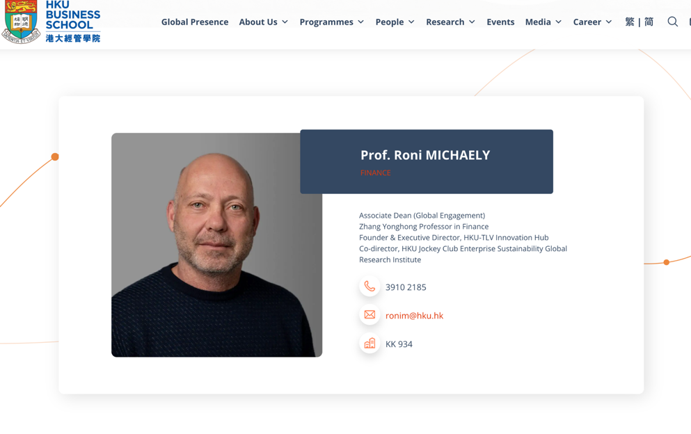
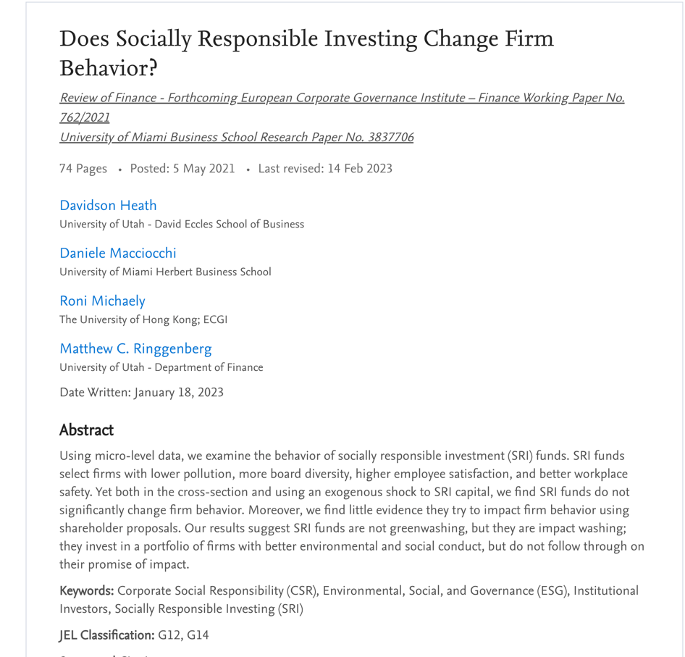
Subject: Enthusiastic Application for PhD under Your Mentorship – Ziti SONG for the 2025 Intake

Dear Prof. Michaely,

I hope this email finds you well. My name is Ziti SONG. I am writing to express my deep interest in pursuing my doctoral studies under your direction at the University of Hong Kong. After reviewing your impactful research, particularly on the relationship between financial markets and sustainability, I discovered that my academic background and study goals closely match your work, and I would be privileged to benefit from your expertise.

Having a Bachelor of Management in Accounting from Shandong University gave me a solid background in advanced financial accounting, securities investing, and financial instruments. The Master of Global Management at the University of Hong Kong enabled me to expand my horizon and gain in-depth knowledge in the international business world, financial markets, and macroeconomic developments.

Apart from my educational background, I have practical experience working for the Insurance Asset Management Association of China, where I experienced the implications of financial policies and governance. Part of my role was analysing the compliance with ESG reporting standards by credit rating agencies, which added depth to my appreciation for the increasing significance of sustainability within the financial world. My exposure to this motivated my research interest in the intersection between corporate governance, finance, and ESG, a focus which is at the centre of your work.

My doctoral research will examine the influence of voluntary climate disclosures on social media—especially Twitter—on firms’ anticipated returns. Because climate-related risks increase and investors insist on disclosure, firms more actively disclose their environmental efforts on the internet. My research addresses the question of whether it increases the value of the firm or affects investor sentiment through signalling. Through textual analysis, I will quantify climate-related material and test its connection with the expectations of the market and the performance of the firm.

Your work, particularly your article “Does Socially Responsible Investing Change Firm Behavior?” offers invaluable insights for my proposed study. Specifically, your findings—that whereas SRI funds invest in firms with better ESG track records but do little in altering the behaviour of firms—raise critical questions on ESG communications’ true impact in relation to the signalling effect. That reflects precisely my interest in whether social media disclosures on climate efforts affect firm value through perception rather than extensive alteration. Your study focuses on critically examining the success of ESG actions and communications, which parallels my interest in understanding whether climate disclosures on Twitter represent true dedication or simply strategic branding.

Overall, I have no doubt that your mentoring will greatly shape my academic career and enrich my research. As I aspire to contribute rigorously and meaningfully to the field, your direction in research design, data processing, and model validation would be invaluable.

Thank you for considering my application. I have attached my resume to this email. If you have any questions, I will be happy to discuss my research plans via online meetings.

Best regards,

Ziti SONG

