https://www.unsw.edu.au/staff/georgios-konstantinou
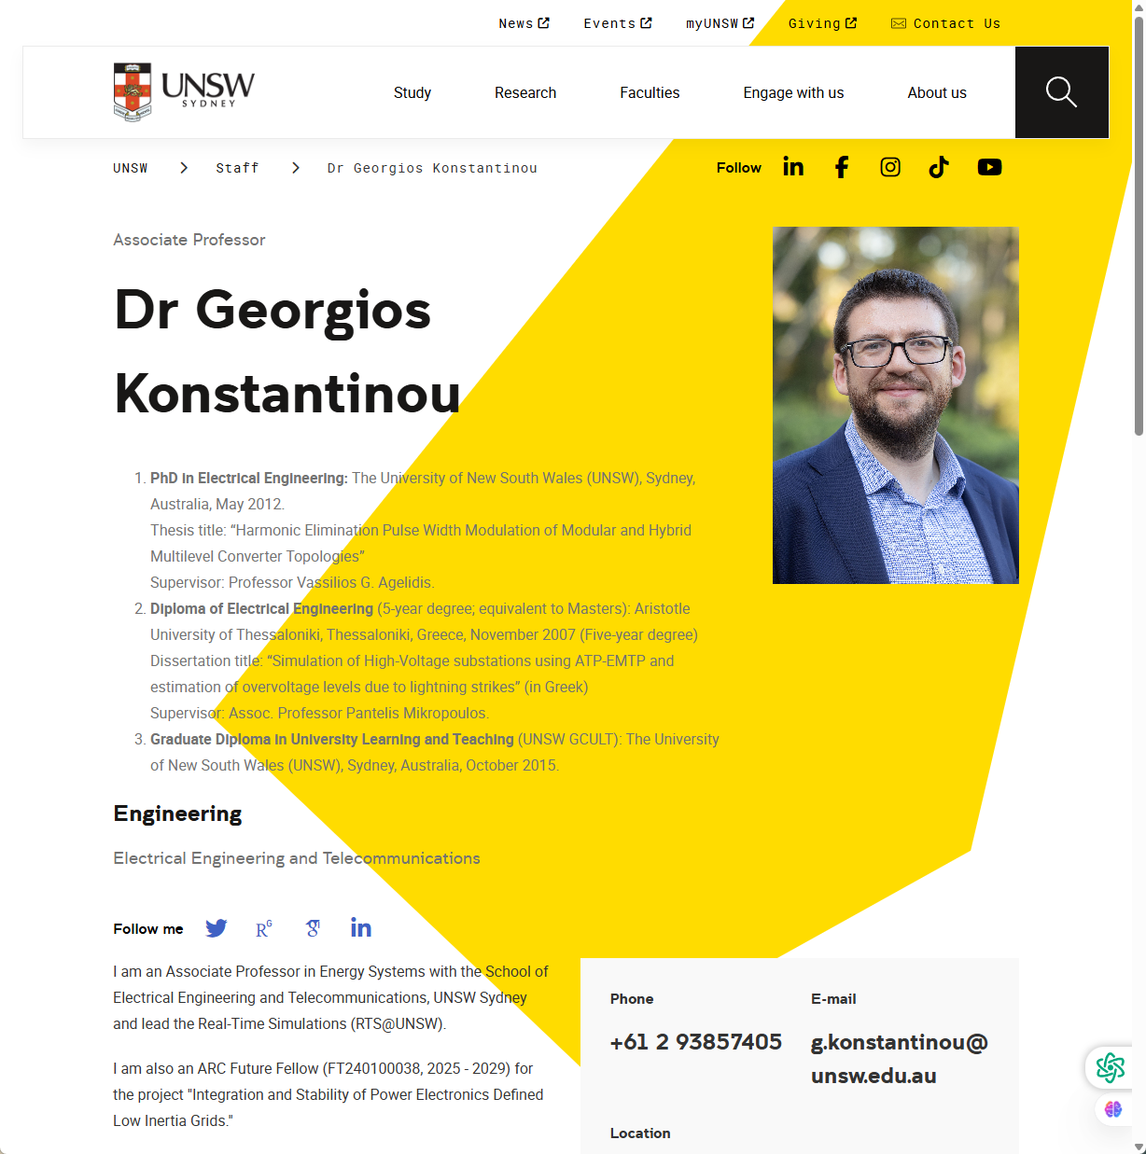

Subject: An enquiry regarding a PhD position from Yina TONG
Dear Associate Professor Konstantinou,
I hope you are doing well.
My name is Yina Tong and I am a current postgraduate student pursuing a Master’s degree in Electrical Engineering (Power Pathway) at Universiti Teknologi Malaysia. I am writing to enquire about the possibility of conducting my future PhD research under your guidance.
Please allow me to briefly introduce my past experience first so that you can get to know me better. At an academic level, I have received systematic training in electrical engineering through my Bachelor’s degree at Harbin University of Science and Technology and my Master’s degree at Universiti Teknologi Malaysia, where I developed a solid foundation in high-voltage systems and power transmission. My bachelor’s graduation thesis focused on the design of COMSOL-based power cable temperature field distribution simulation and an online monitoring system. Building on this experience, I have recently been further working on electromagnetic modelling and multiphysics simulation using COMSOL, with particular emphasis on cable structures, field distribution, and the skin effect in conductors. Professionally, I served as a simulation engineer at TBEA Co., Ltd. (a cable research institute), where I built a comprehensive library of cable models and assisted in a joint research project on AC resistance measurement of large conductors. During this project, I was required to verify the practical effect of electrical insulation design in split conductor structures in high-frequency environments and to predict the current distribution via simulations to provide a quantitative basis for design improvement. I adjusted the boundary condition from electrically insulated to magnetically insulated and eventually greatly improved the accuracy of current distribution simulation, achieving a successful patent application. These experiences have shaped both my technical abilities and research mindset. They have also inspired me to further explore the challenges posed by integrating renewable energy into transmission systems.
My proposed research centres on the integration of high-voltage direct current (HVDC) systems into renewable energy grids. With increasing renewable penetration, power systems face greater demands for flexibility and stability. HVDC, combined with advanced control strategies, offers a promising solution to these challenges. Building on my experience in electromagnetic modelling and high-voltage system simulation, I aim to explore how converter control (especially in grid-forming configurations) can improve system response under frequency disturbances. My goal is to investigate control strategies that enhance the dynamic adaptability of HVDC systems in weak grid scenarios, focusing on the interaction between structural behaviour and control performance.
Your work strongly inspired me, especially your paper Frequency Domain Inertia Design of Grid-Forming Converters, in which you use a frequency-domain approach to synthetic inertia and treat the inertia factor as a transfer function rather than a static parameter. This design presents an intelligent solution to frequency-disturbance issues, since it enables GFM converters to provide firm support in low-frequency ranges, while remaining responsive and stable in high-frequency circumstances. This paper greatly influenced how I thought about HVDC system control. Thanks to this paper, I understood that robust renewable integration is not only a physical infrastructure problem - it is also an adaptive control design problem. Your approach - using frequency characteristics to vary system response - provides a compelling alternative method to traditional inertia-based models and illustrates the critical role of grid-forming converter behaviour under weak-grid scenarios. If I could work in your team, I would maximise the effect of my foundation in electromagnetic modelling and physical system analysis and develop advanced control strategies under your guidance. I believe your research represents the forefront of resilient, low-carbon power systems, and I would be honoured to contribute to it.
Thank you for reading this email. Please kindly find the attached CV for more information about my research experience. It would be a great honour of mine to further discuss with you about my future research and PhD possibility.
I look forward to hearing from you.
Sincerely,
Yina Tong

